SQL Select Into

🌟 Definition
# Source: AI Source: Provided by: [Data Path: Persons Table -> ID Column: 1, Name_En Column: Motasem Essam] -> From: [ChatGPT] on [6/11/2026]
SQL SELECT INTO is a statement used to create a new table and copy data from an existing table into the new table.
It combines two operations into one:
- SELECT → Retrieves data.
- CREATE TABLE → Creates a new table.
The new table is automatically created with the selected data.

🎯 Purpose
# Source: AI Source: Provided by: [Data Path: Persons Table -> ID Column: 1, Name_En Column: Motasem Essam] -> From: [ChatGPT] on [6/11/2026]
SELECT INTO is used to:
- Create backup tables
- Archive old data
- Create temporary tables
- Copy data for testing
- Generate reports
- Create a new table from query results

🧠 How It Works
# Source: AI Source: Provided by: [Data Path: Persons Table -> ID Column: 1, Name_En Column: Motasem Essam] -> From: [ChatGPT] on [6/11/2026]
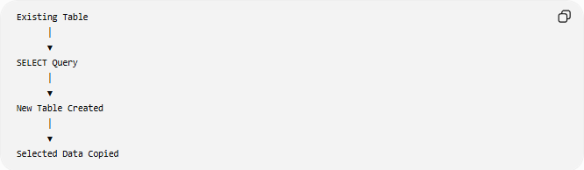
Existing Table
│
▼
SELECT Query
│
▼
New Table Created
│
▼
Selected Data Copied

📝 Syntax
# Source: AI Source: Provided by: [Data Path: Persons Table -> ID Column: 1, Name_En Column: Motasem Essam] -> From: [ChatGPT] on [6/11/2026]
Copy All Columns
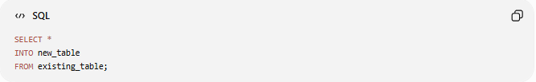
SELECT *
INTO new_table
FROM existing_table;

Copy Specific Columns
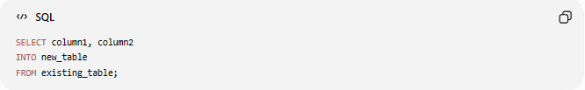
SELECT column1, column2
INTO new_table
FROM existing_table;

Copy Filtered Data
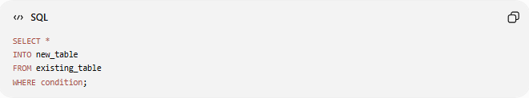
SELECT *
INTO new_table
FROM existing_table
WHERE condition;

📚 Example 1: Copy an Entire Table
# Source: AI Source: Provided by: [Data Path: Persons Table -> ID Column: 1, Name_En Column: Motasem Essam] -> From: [ChatGPT] on [6/11/2026]
Original Table
Customers
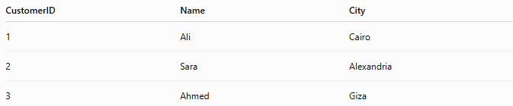
CustomerID | Name | City
1 | Ali | Cairo
2 | Sara | Alexandria
3 | Ahmed | Giza

SQL Statement
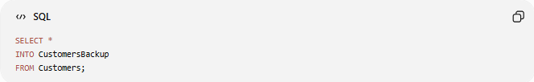
SELECT *
INTO CustomersBackup
FROM Customers;

Result
A new table named CustomersBackup is created.
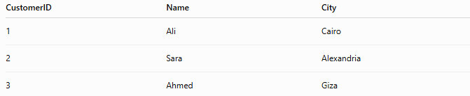
CustomerID | Name | City
1 | Ali | Cairo
2 | Sara | Alexandria
3 | Ahmed | Giza

📚 Example 2: Copy Selected Columns
# Source: AI Source: Provided by: [Data Path: Persons Table -> ID Column: 1, Name_En Column: Motasem Essam] -> From: [ChatGPT] on [6/11/2026]
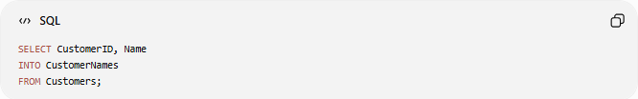
SELECT CustomerID, Name
INTO CustomerNames
FROM Customers;

Result
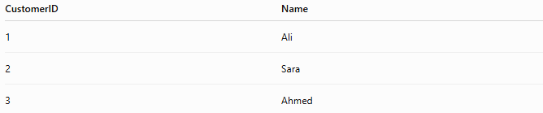
CustomerID | Name
1 | Ali
2 | Sara
3 | Ahmed
Only the selected columns are copied.

📚 Example 3: Copy Filtered Records
# Source: AI Source: Provided by: [Data Path: Persons Table -> ID Column: 1, Name_En Column: Motasem Essam] -> From: [ChatGPT] on [6/11/2026]
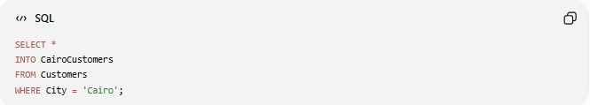
SELECT *
INTO CairoCustomers
FROM Customers
WHERE City = 'Cairo';

Result
CustomerID | Name | City
1 | Ali | Cairo
Only customers from Cairo are copied.

📚 Example 4: Copy Data from Multiple Tables
# Source: AI Source: Provided by: [Data Path: Persons Table -> ID Column: 1, Name_En Column: Motasem Essam] -> From: [ChatGPT] on [6/11/2026]
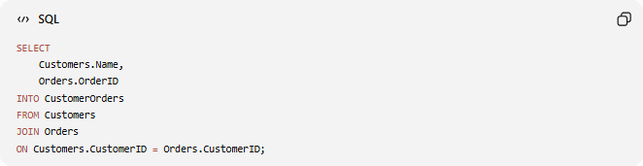
SELECT
Customers.Name,
Orders.OrderID
INTO CustomerOrders
FROM Customers
JOIN Orders
ON Customers.CustomerID = Orders.CustomerID;

Result
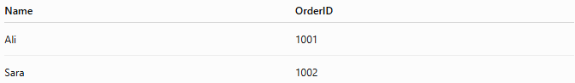
Name | OrderID
Ali | 1001
Sara | 1002
A new table is created from the result of a JOIN.

🧪 Complete Test Example (SQL Server)

1️⃣ Create Source Table
# Source: AI Source: Provided by: [Data Path: Persons Table -> ID Column: 1, Name_En Column: Motasem Essam] -> From: [ChatGPT] on [6/11/2026]
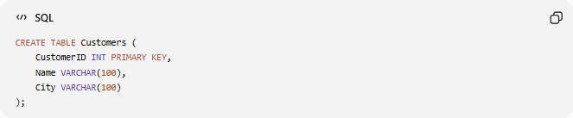
CREATE TABLE Customers (
CustomerID INT PRIMARY KEY,
Name VARCHAR(100),
City VARCHAR(100)
);

2️⃣ Insert Sample Data
# Source: AI Source: Provided by: [Data Path: Persons Table -> ID Column: 1, Name_En Column: Motasem Essam] -> From: [ChatGPT] on [6/11/2026]
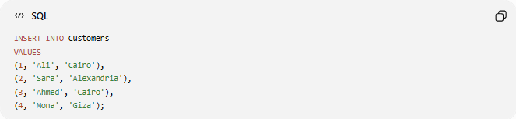
INSERT INTO Customers
VALUES
(1, 'Ali', 'Cairo'),
(2, 'Sara', 'Alexandria'),
(3, 'Ahmed', 'Cairo'),
(4, 'Mona', 'Giza');

3️⃣ View the Source Table
# Source: AI Source: Provided by: [Data Path: Persons Table -> ID Column: 1, Name_En Column: Motasem Essam] -> From: [ChatGPT] on [6/11/2026]
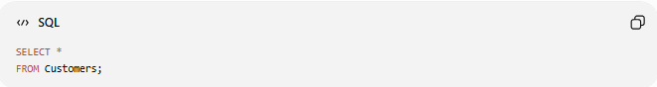
SELECT *
FROM Customers;
Result
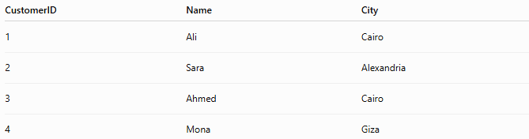
CustomerID | Name | City
1 | Ali | Cairo
2 | Sara | Alexandria
3 | Ahmed | Cairo
4 | Mona | Giza

4️⃣ Create a Backup Table
# Source: AI Source: Provided by: [Data Path: Persons Table -> ID Column: 1, Name_En Column: Motasem Essam] -> From: [ChatGPT] on [6/11/2026]
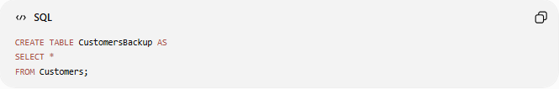
CREATE TABLE CustomersBackup AS
SELECT *
FROM Customers;

If you only want to create the table structure (without copying data):
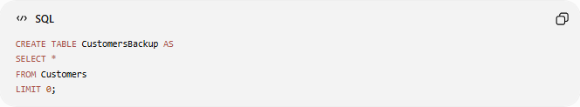
CREATE TABLE CustomersBackup AS
SELECT *
FROM Customers
LIMIT 0;

5️⃣ Verify the Backup
# Source: AI Source: Provided by: [Data Path: Persons Table -> ID Column: 1, Name_En Column: Motasem Essam] -> From: [ChatGPT] on [6/11/2026]
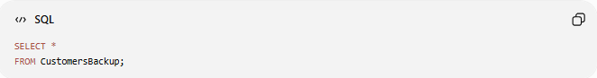
SELECT *
FROM CustomersBackup;
Result
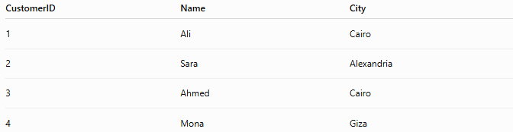
CustomerID | Name | City
1 | Ali | Cairo
2 | Sara | Alexandria
3 | Ahmed | Cairo
4 | Mona | Giza

Real Example

prepared commands

1️⃣ Create Source Table
# Source: ScreenShot Source: Provided by: [Persons Table -> ID Column: 1, Name_En Column: Motasem Essam] -> Tool: [Automation Table -> ID Column: 16, Name_En Column: Screen Capture] -> From [Operating System: Wampserver64 -> phpmyadmin] on [6/11/2026]
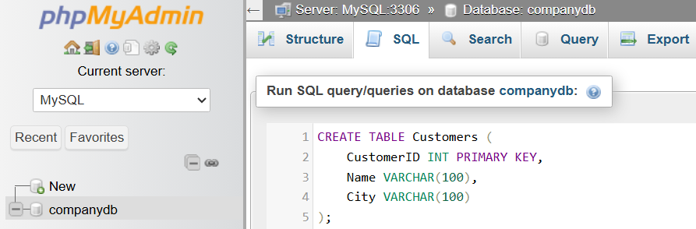
CREATE TABLE Customers (
CustomerID INT PRIMARY KEY,
Name VARCHAR(100),
City VARCHAR(100)
);
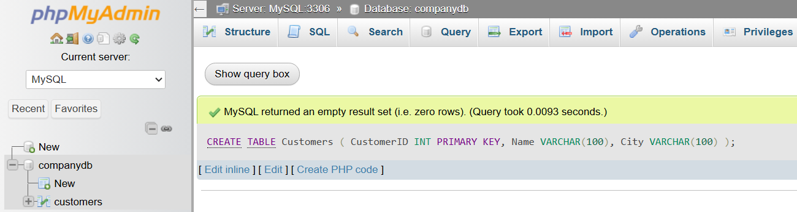

2️⃣ Insert Sample Data
# Source: ScreenShot Source: Provided by: [Persons Table -> ID Column: 1, Name_En Column: Motasem Essam] -> Tool: [Automation Table -> ID Column: 16, Name_En Column: Screen Capture] -> From [Operating System: Wampserver64 -> phpmyadmin] on [6/11/2026]
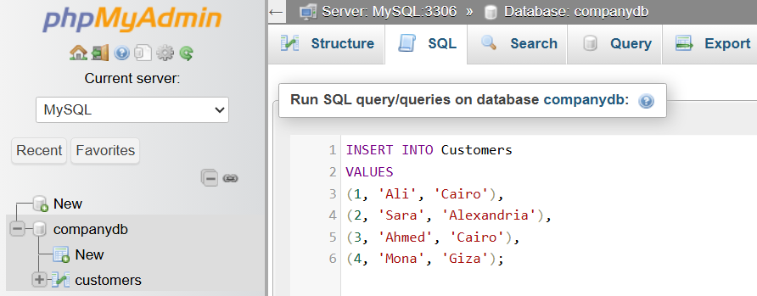
INSERT INTO Customers
VALUES
(1, 'Ali', 'Cairo'),
(2, 'Sara', 'Alexandria'),
(3, 'Ahmed', 'Cairo'),
(4, 'Mona', 'Giza');
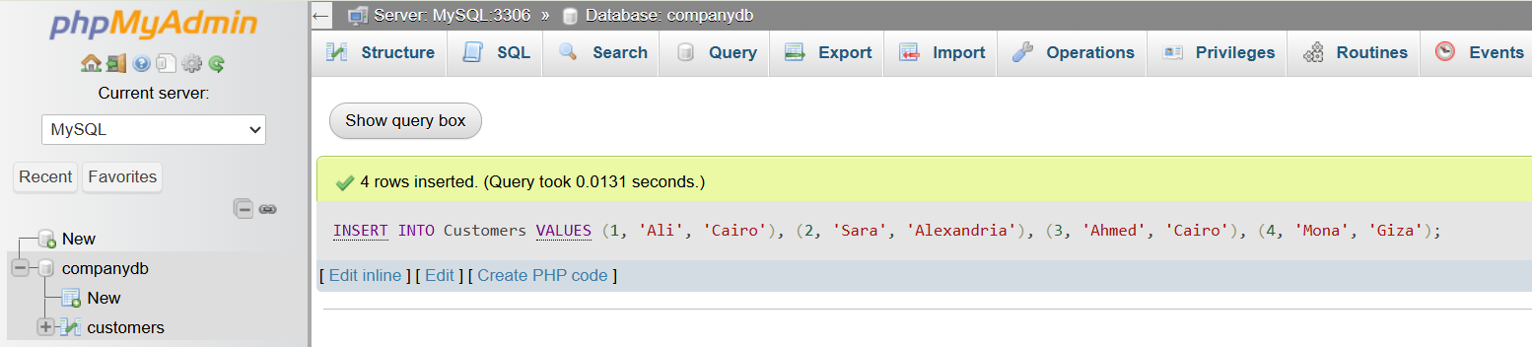

3️⃣ View the Source Table
# Source: ScreenShot Source: Provided by: [Persons Table -> ID Column: 1, Name_En Column: Motasem Essam] -> Tool: [Automation Table -> ID Column: 16, Name_En Column: Screen Capture] -> From [Operating System: Wampserver64 -> phpmyadmin] on [6/11/2026]
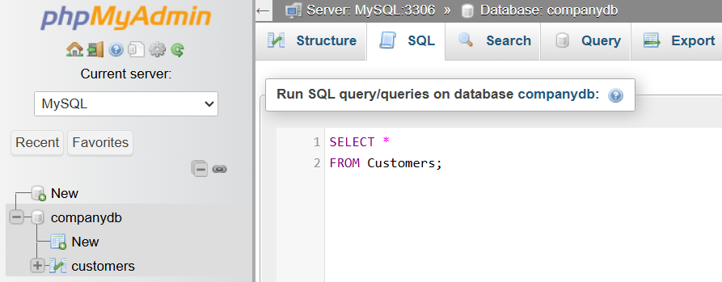
SELECT *
FROM Customers;
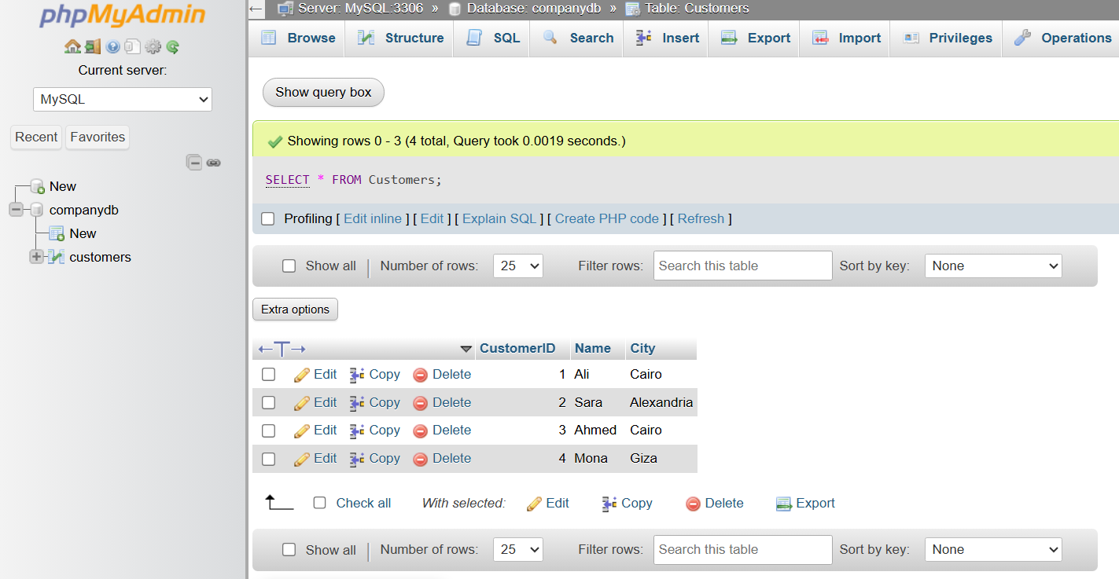

basic command

4️⃣ Create a Backup Table
# Source: ScreenShot Source: Provided by: [Persons Table -> ID Column: 1, Name_En Column: Motasem Essam] -> Tool: [Automation Table -> ID Column: 16, Name_En Column: Screen Capture] -> From [Operating System: Wampserver64 -> phpmyadmin] on [6/11/2026]
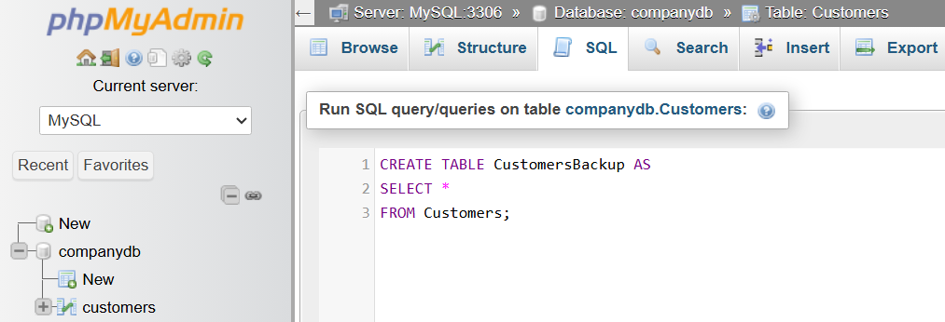
CREATE TABLE CustomersBackup AS
SELECT *
FROM Customers;
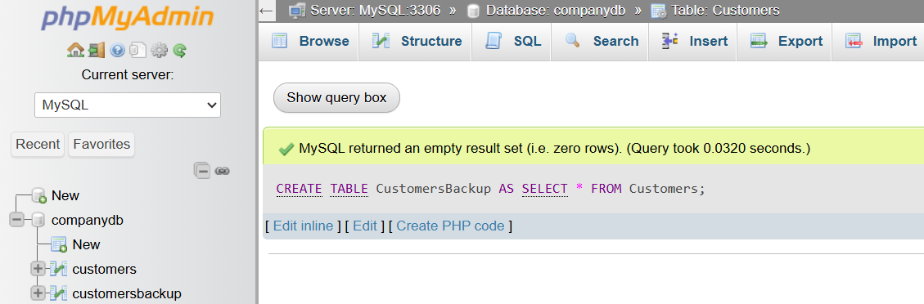

5️⃣ Verify the Backup
# Source: ScreenShot Source: Provided by: [Persons Table -> ID Column: 1, Name_En Column: Motasem Essam] -> Tool: [Automation Table -> ID Column: 16, Name_En Column: Screen Capture] -> From [Operating System: Wampserver64 -> phpmyadmin] on [6/11/2026]
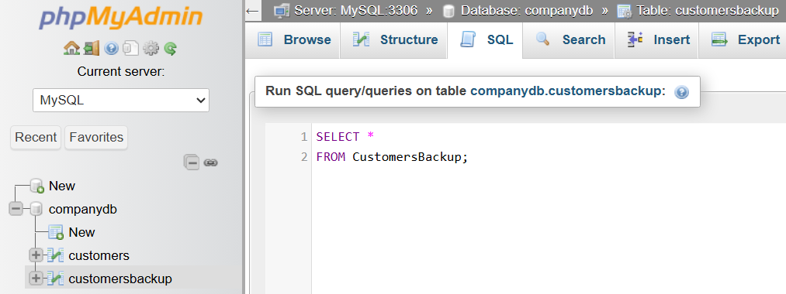
SELECT *
FROM CustomersBackup;
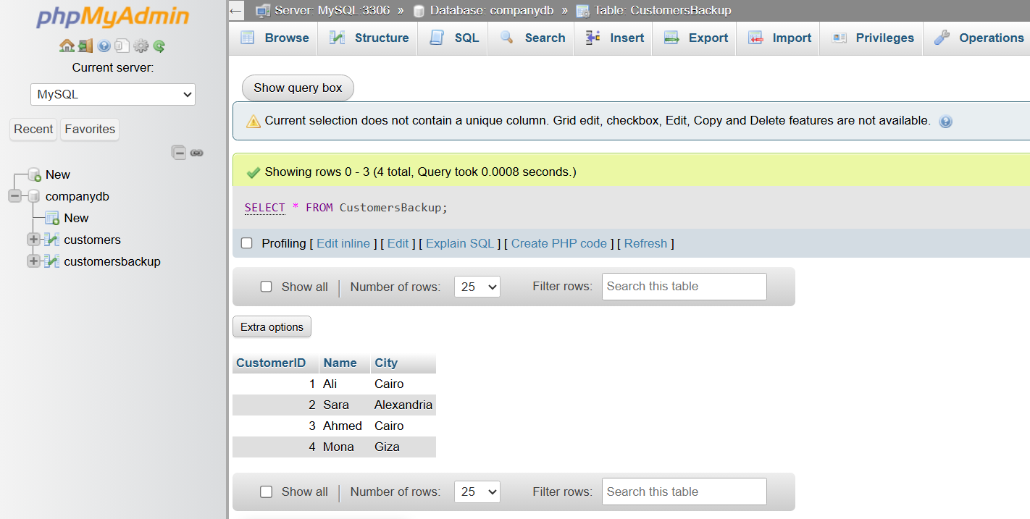

⚠️ What Gets Copied?
# Source: AI Source: Provided by: [Data Path: Persons Table -> ID Column: 1, Name_En Column: Motasem Essam] -> From: [ChatGPT] on [6/11/2026]
✅ Copied
- Data
- Column names
- Data types

❌ Usually Not Copied
# Source: AI Source: Provided by: [Data Path: Persons Table -> ID Column: 1, Name_En Column: Motasem Essam] -> From: [ChatGPT] on [6/11/2026]
- Primary Keys
- Foreign Keys
- Indexes
- Constraints
- Triggers
- Auto Increment/Identity properties
(Behavior may vary depending on the database system.)

⚖️ SELECT INTO vs INSERT INTO SELECT
# Source: AI Source: Provided by: [Data Path: Persons Table -> ID Column: 1, Name_En Column: Motasem Essam] -> From: [ChatGPT] on [6/11/2026]
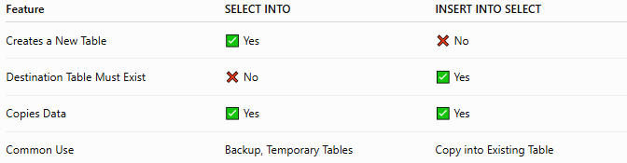
Feature | SELECT INTO | INSERT INTO SELECT
Creates a New Table | ✅ Yes | ❌ No
Destination Table Must Exist | ❌ No | ✅ Yes
Copies Data | ✅ Yes | ✅ Yes
Common Use | Backup, Temporary Tables | Copy into Existing Table

SELECT INTO
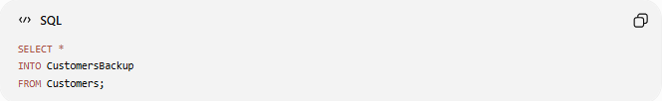
SELECT *
INTO CustomersBackup
FROM Customers;
Creates CustomersBackup automatically.

INSERT INTO SELECT
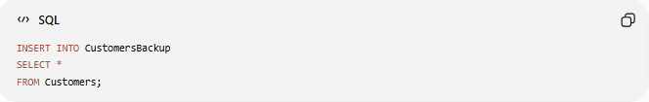
INSERT INTO CustomersBackup
SELECT *
FROM Customers;
Copies data into an existing table.

🌍 Database Support
# Source: AI Source: Provided by: [Data Path: Persons Table -> ID Column: 1, Name_En Column: Motasem Essam] -> From: [ChatGPT] on [6/11/2026]
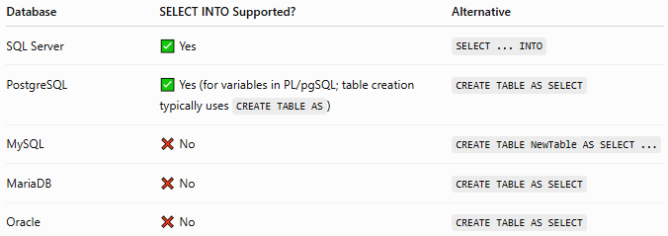
Database | SELECT INTO Supported? | Alternative
SQL Server | ✅ Yes | SELECT ... INTO
PostgreSQL | ✅ Yes (for variables in PL/pgSQL; table creation typically uses CREATE TABLE AS) | CREATE TABLE AS SELECT
MySQL | ❌ No | CREATE TABLE NewTable AS SELECT ...
MariaDB | ❌ No | CREATE TABLE AS SELECT
Oracle | ❌ No | CREATE TABLE AS SELECT

🛠️ MySQL Alternative
# Source: AI Source: Provided by: [Data Path: Persons Table -> ID Column: 1, Name_En Column: Motasem Essam] -> From: [ChatGPT] on [6/11/2026]
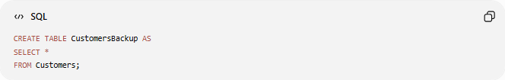
Instead of SELECT INTO, MySQL uses:
CREATE TABLE CustomersBackup AS
SELECT *
FROM Customers;
This creates a new table and copies the selected data.

📊 Common Use Cases
# Source: AI Source: Provided by: [Data Path: Persons Table -> ID Column: 1, Name_En Column: Motasem Essam] -> From: [ChatGPT] on [6/11/2026]
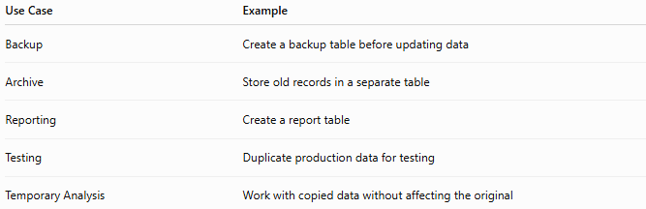
Use Case | Example
Backup | Create a backup table before updating data
Archive | Store old records in a separate table
Reporting | Create a report table
Testing | Duplicate production data for testing
Temporary Analysis | Work with copied data without affecting the original

🔢 SELECT INTO Workflow
# Source: AI Source: Provided by: [Data Path: Persons Table -> ID Column: 1, Name_En Column: Motasem Essam] -> From: [ChatGPT] on [6/11/2026]
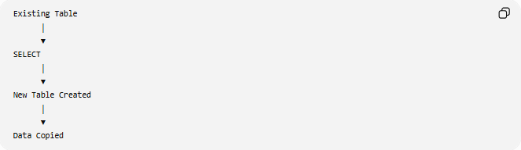
Existing Table
│
▼
SELECT
│
▼
New Table Created
│
▼
Data Copied

🧠 Simple Analogy
# Source: AI Source: Provided by: [Data Path: Persons Table -> ID Column: 1, Name_En Column: Motasem Essam] -> From: [ChatGPT] on [6/11/2026]
Imagine you have a folder called:
Customers
Using SELECT INTO is like saying:
"Create a brand-new folder named CustomersBackup and copy all the documents from the Customers folder into it."
The original folder remains unchanged, and a new copy is created automatically.

🧭 Summary
# Source: AI Source: Provided by: [Data Path: Persons Table -> ID Column: 1, Name_En Column: Motasem Essam] -> From: [ChatGPT] on [6/11/2026]
SQL SELECT INTO creates a new table and fills it with data selected from an existing table. It is commonly used for backups, archiving, reporting, and testing. Unlike INSERT INTO SELECT, which copies data into an existing table, SELECT INTO automatically creates the destination table before copying the selected rows.

